Reading resources you can use at home

Reading Rockets
http://www.readingrockets.org/article/get-ready-summer-ideas-teachers-share-families#online

Start with a Book
http://www.startwithabook.org/

Scholastic
http://www.scholastic.com/ups/campaigns/src-2015#age_screener/cleanup

Imagination Soup
http://imaginationsoup.net/2015/05/summer-reading-list-for-kids/

Read Write Think
http://www.readwritethink.org/parent-afterschool-resources/

Barnes and Noble
http://www.barnesandnoble.com/u/summer-reading/379003570/

Michigan Electronic Library
http://kids.mel.org/

Starfall
www.starfall.com

Storyline Online
www.storylineonline.net

ABCya
www.abcya.com

RAZ Kids
www.raz-kids.com
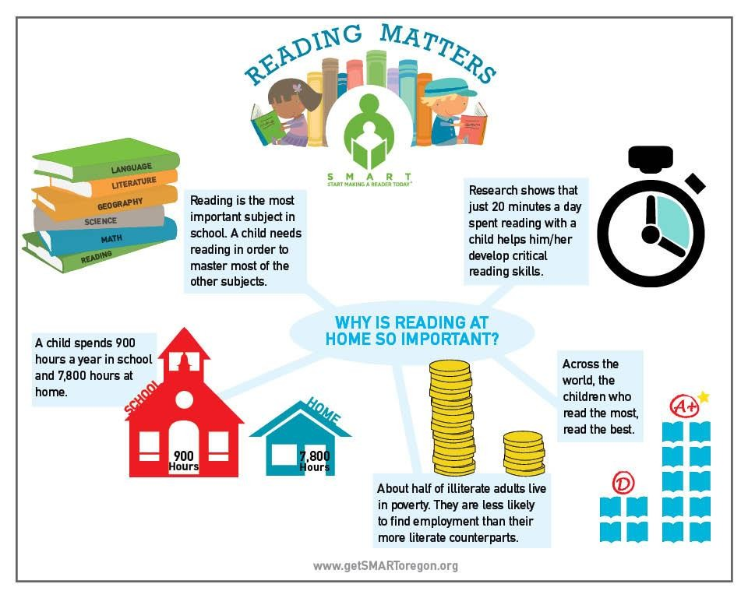DID YOU KNOW?

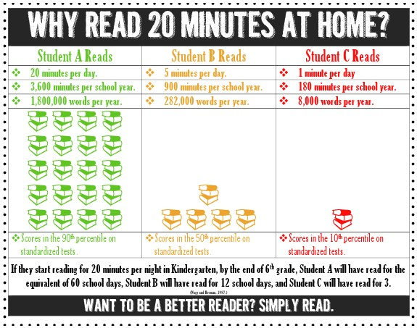
Parent’s Read-At-Home Plan for

Student Success

Reading with your child is a proven way to promote early literacy. One of the most important things you can do to prepare your child for his/her future is helping to make sure that your child is reading at grade level by third grade. You can influence your child’s success in school by making reading a daily routine in your home. Research shows that students who read at least 20 minutes per day score in the 90th percentile on standardized tests. Do you want to help your child to be successful in school? They simply need to read.

WHAT CAN I DO TO SUPPORT MY CHILD?

Read at home with your child daily (at least 20 minutes) with books they enjoy. Some ways to do this:

Read out loud to your child.
Listen to your child read.
Echo read (you read a line, then they repeat).
Read together at the same time.
Reread or retell favorite stories.
Talk to your child about the reading.

As you read:

Ask your child to share what they remember.
Ask questions about the reading.
Talk about your favorite parts.
Talk about what you have learned.
Talk about how the pictures in the book connect to the words on the page.
Help connect the reading to your child’s life or other books they’ve read.
Michigan Third Grade Reading Law

A Parent Guide to Public Act 306

What you should know as a parent?

In October 2016, Michigan lawmakers passed Public Act 306 in an effort to boost reading achievement.
Beginning in Kindergarten, your child’s literacy progress will be closely monitored by your child’s teachers.
Each child will have a reading plan. This means that your child’s teacher and school will work with your child to find where your child needs support and create a plan to support your child. The plan will include:
-extra instruction or support in areas of need
-ongoing progress checks
-at home reading plan (20 minutes of reading outside of the school day)
-Your child may be encouraged to participate in summer reading programs
Extra support in your child’s individualized reading plan will occur in small group or one-on- one instruction during the school day. Your child will not miss regular reading instruction.
Based on this law, beginning in the 2019-2020 school year, 3rd graders must score less than
one year behind on state reading assessments in order to be promoted to 4th grade. 3rd graders can also be promoted to 4th grade if they prove to be at grade level through an alternate assessment or a portfolio of work.

RESEARCH DOES NOT SUPPORT RETENTION AND SHOWS THAT STUDENTS WHO ARE
RETAINED ARE NO BETTER OFF THAN THEIR PEERS WHO ARE PROMOTED TO THE NEXT GRADE LEVEL. HARTLAND CONSOLIDATED SCHOOLS SUPPORTS THE PROMOTION OF STUDENTS TO THE NEXT GRADE LEVEL WITH CONTINUED SUPPORT BASED ON ACADEMIC NEED.

